Ref. No.: IVM/KBIPER/Ex-Cu/2025-26/ Date: 20/04/2026

REPORT

01 | Date of activity | 15/04/2026 & 16/04/2026
02 | Total Attendance | No. of Participated Students: 450  No. of Staff: 40
03 | Occasion of Activity | “EUPHORIA ZEST 2026.”-Style Scramble Day, Halloween Day, Bollywood Day & Group Day
04. | Objective | The objective of organizing Style Scramble Day, Halloween Day, Bollywood Day, and Group Day was to provide a platform for students to showcase creativity, confidence, and individuality through themed activities, while promoting teamwork, coordination, and active participation beyond academics.
 | Summary Report | Euphoria Zest 2026 was celebrated with great enthusiasm and vibrant participation at IVM’S Krishnarao Bhegade Institute of Pharmaceutical Education and Research. The event brought together students from all academic years, creating a lively and colorful campus atmosphere. The celebration included multiple themed activities such as Style Scramble Day, Halloween Day, Bollywood Day, and Group Day conducted over 15th and 16th April 2026. Style Scramble Day showcased innovative fashion and confidence through ramp walks, while Halloween Day added excitement with creative and imaginative costumes.  Bollywood Day highlighted cultural expression, where students represented iconic characters from Indian cinema with enthusiasm and creativity. Group Day emphasized teamwork and coordination, as students participated in synchronized themes and group performances, reflecting unity and collaboration.Cultural performances, coordinated by Ms. Ashvini Joshi and Ms. Shweta Mantri, featured dance and musical presentations that highlighted the diverse talents of the students. The entire program was conducted smoothly under the guidance of the Principal and faculty members, with active support from the student council.  Participants were evaluated based on creativity, presentation, and coordination, and outstanding performances were recognized and appreciated. Overall, Euphoria Zest 2026 successfully created a joyful, energetic, and memorable experience, strengthening student interaction and promoting holistic development.
06 | Activity co-coordinator | Ms. A.V.Joshi  Ms. Shweta Mantri

Geotag photos of “Euphoria Zest 2026’’

Principal Addressing the Gathering  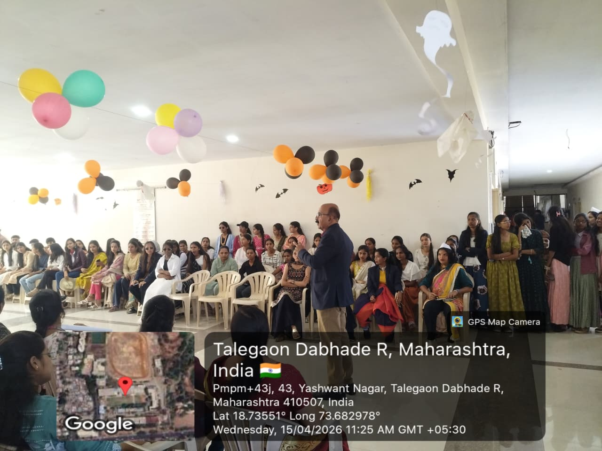  Halloween Day – Creative Costumes  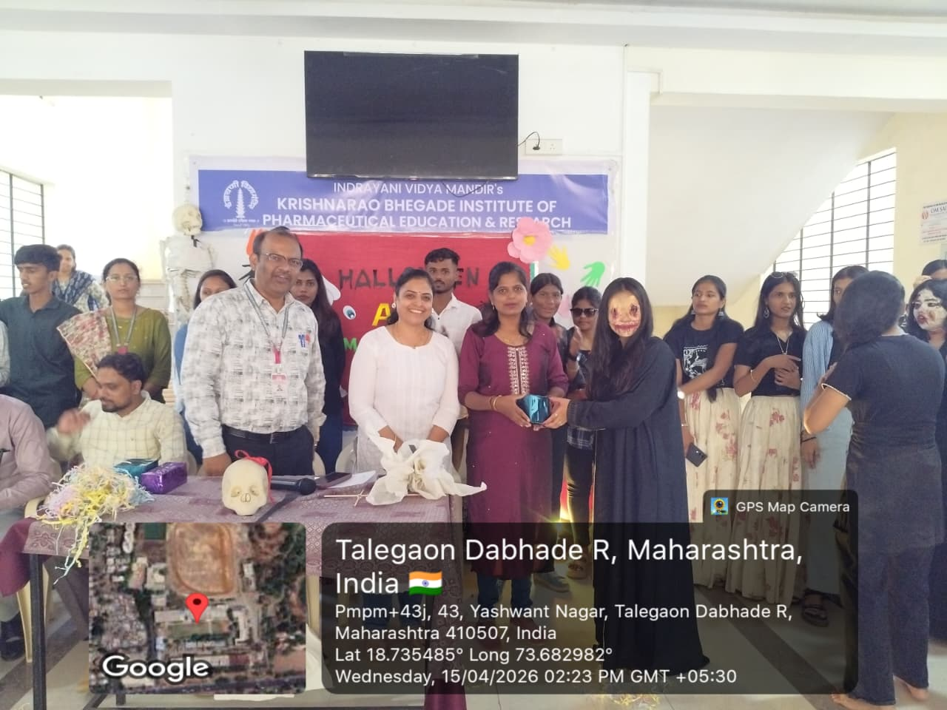  Cultural Dance & Music Performances  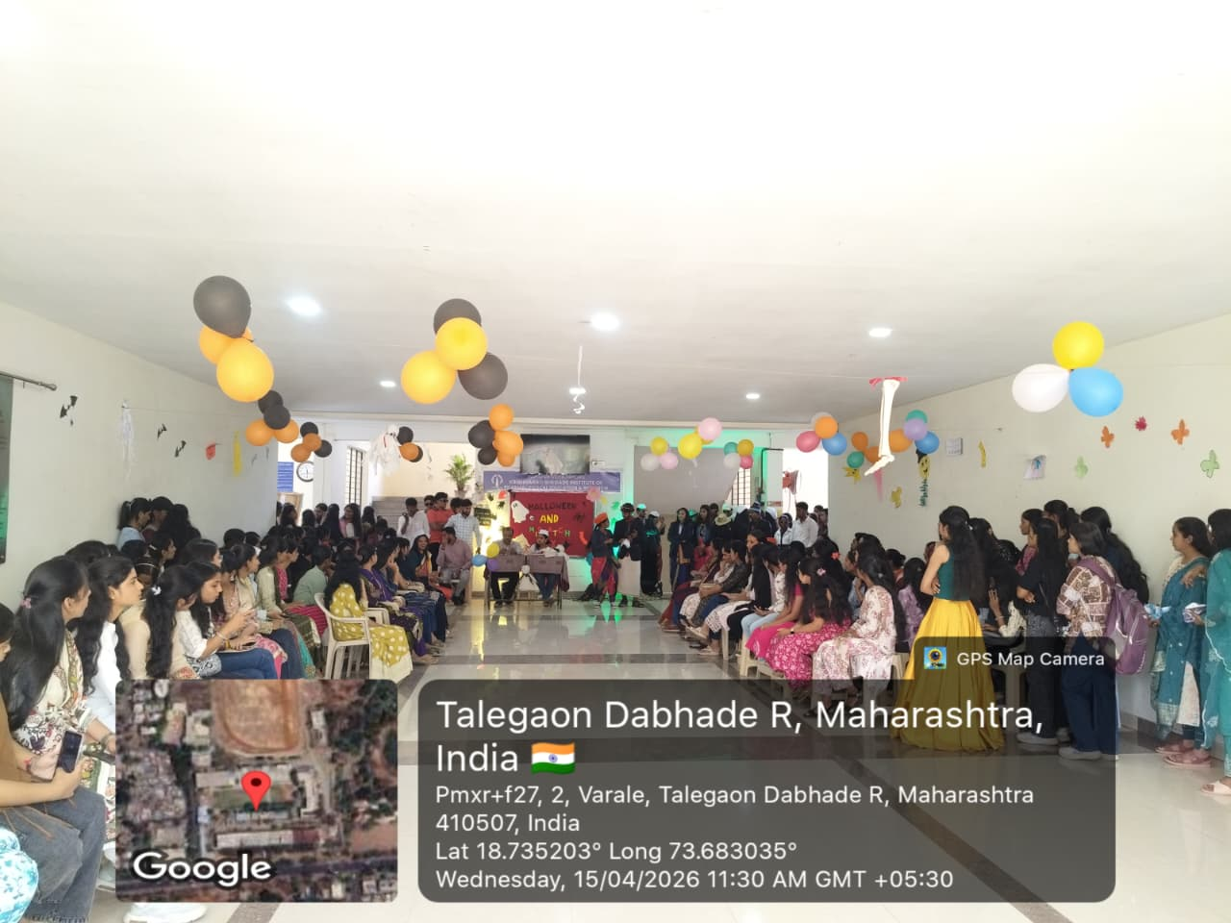 | Style Scramble Day – Ramp Walk  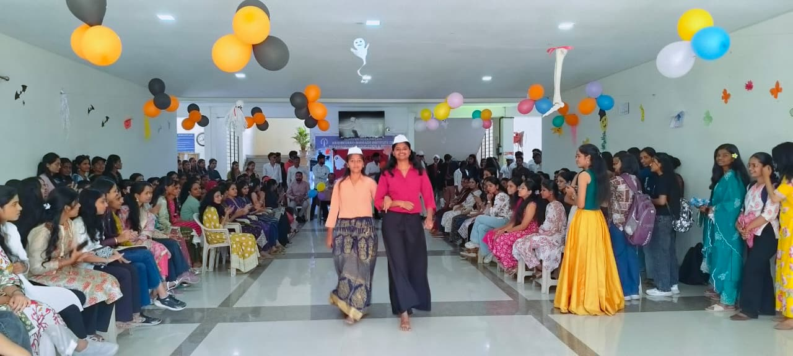  Bollywood Day – Character Representation  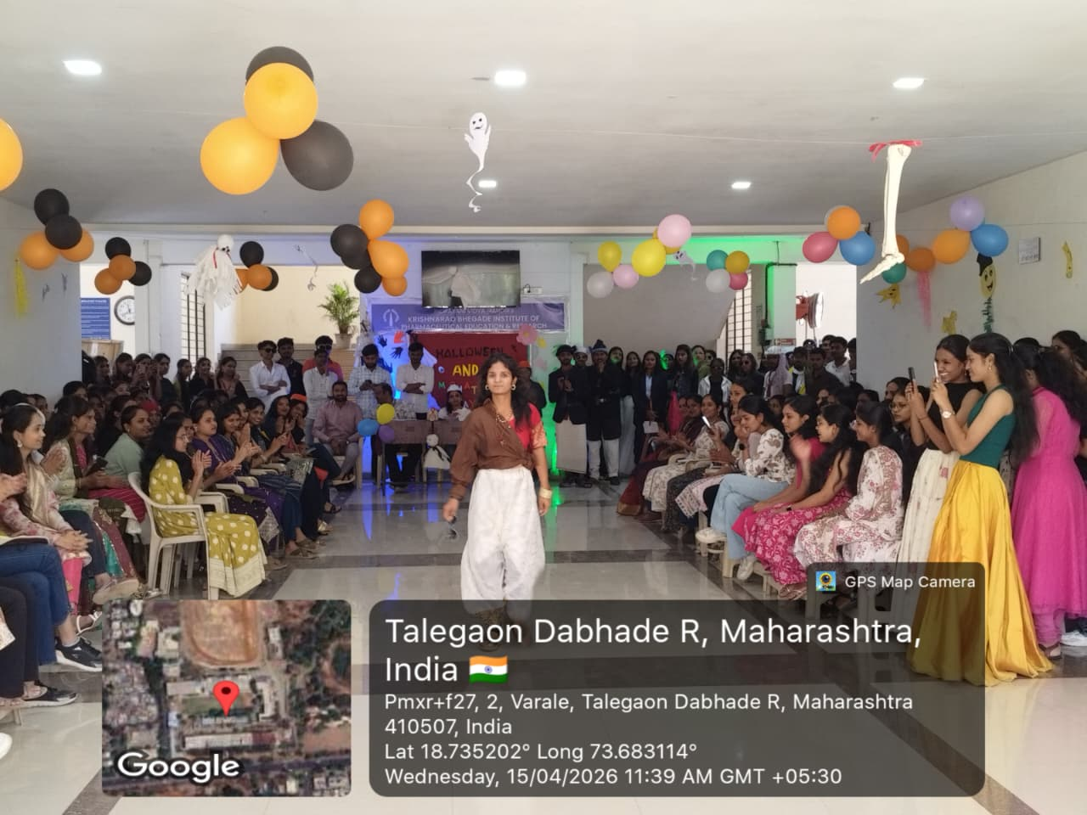  Group Day – Team Performances  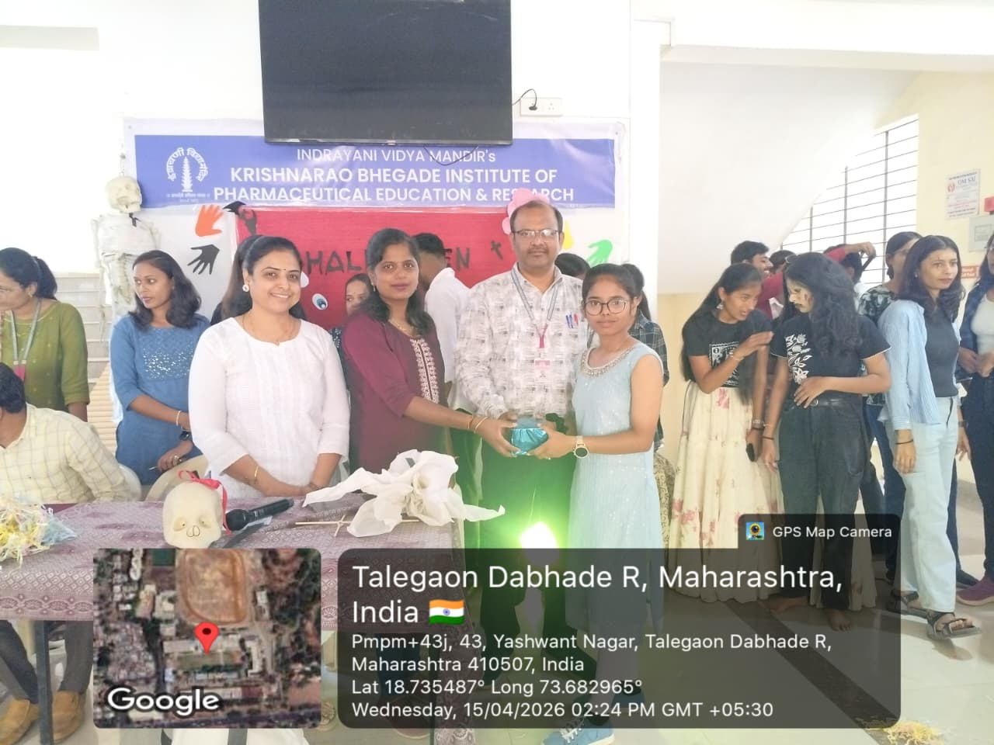

Extracurricular Coordinator IQAC Head HOD Principal
Ms. A.V.Joshi Dr.Y.B.Zambare Dr.G.S.Shinde Dr. Sanjay R. Arote
Ms. Shweta Mantri

